National College of Ireland

BSc (Honours) in Computing Software Development
Academic Year 2025/2026

Student Name: Eoin Fitzsimons
Student Number: X23151374
Student Email: x23151374@student.ncirl.ie

Project Title: Momentum - Multi-Discipline Motorsport Simulation System
Technical Report

Contents
1 Contents 2
2 Executive Summary 8
3 Introduction 8
3.1 Background 8
3.2 Aims 9
3.3 Technology 9
3.4 Structure 10
4 Requirements 11
4.1 Functional Requirements 11
4.1.1 HIGH Priority (Must Have - Core Gameplay): 11
4.1.2 MEDIUM Priority (Career Mode Depth): 11
4.1.3 LOW Priority (Polish & Advanced Features): 12
5 Use Cases 12
5.1 UC-1: Read Driver Details 12
5.1.1 Scope 12
5.1.2 Description 12
5.1.3 Actors 13
5.1.4 Use Case Diagram 13
5.1.5 Flow Description 13
5.2 UC-2: Read Race Configuration 13
5.2.1 Scope 13
5.2.2 Description 13
5.2.3 Actors 13
5.2.4 Use Case Diagram 14
5.2.5 Flow Description 14
5.3 UC-3: Create Race Result 14
5.3.1 Scope 14
5.3.2 Description 14
5.3.3 Actors 14
5.3.4 Flow Description 14
5.4 UC-4: Read Race Results 15
5.4.1 Scope 15
5.4.2 Description 15
5.4.3 Actors 15
5.4.4 Use Case Diagram 15
5.4.5 Flow Description 15
5.5 UC-5: Read Championship Details 16
5.5.1 Scope 16
5.5.2 Description 16
5.5.3 Actors 16
5.5.4 Use Case Diagram 16
5.5.5 Flow Description 16
5.6 UC-6: Update Championship Standings 16
5.6.1 Scope 16
5.6.2 Description 16
5.6.3 Actors 16
5.6.4 Use Case Diagram 17
5.6.5 Flow Description 17
5.7 UC-7: Create Race Event 17
5.7.1 Scope 17
5.7.2 Description 17
5.7.3 Actors 17
5.7.4 Use Case Diagram 17
5.7.5 Flow Description 17
5.8 UC-8: Read Race Schedule 18
5.8.1 Scope 18
5.8.2 Description 18
5.8.3 Actors 18
5.8.4 Use Case Diagram 18
5.8.5 Flow Description 18
5.9 UC-9: Update Race Status 19
5.9.1 Scope 19
5.9.2 Description 19
5.9.3 Actors 19
5.9.4 Use Case Diagram 19
5.9.5 Flow Description 19
5.10 UC-10: Create Championship 20
5.10.1 Scope 20
5.10.2 Description 20
5.10.3 Actors 20
5.10.4 Use Case Diagram 20
5.10.5 Flow Description 20
5.11 UC-11: Read Team Details 21
5.11.1 Scope 21
5.11.2 Description 21
5.11.3 Actors 21
5.11.4 Use Case Diagram 21
5.11.5 Flow Description 21
5.12 UC-12: Create New Team 21
5.12.1 Scope 21
5.12.2 Description 21
5.12.3 Actors 22
5.12.4 Use Case Diagram 22
5.12.5 Flow Description 22
5.13 UC-13: Read Team Details (player team) 22
5.13.1 Scope 22
5.13.2 Description 22
5.13.3 Actors 22
5.13.4 Use Case Diagram 23
5.13.5 Flow Description 23
5.14 UC-14: Update Team Attributes 23
5.14.1 Scope 23
5.14.2 Description 23
5.14.3 Actors 23
5.14.4 Use Case Diagram 23
5.14.5 Flow Description 23
5.15 UC-15: Read Available Drivers 24
5.15.1 Scope 24
5.15.2 Description 24
5.15.3 Actors 24
5.15.4 Use Case Diagram 24
5.15.5 Flow Description 24
5.16 UC-16: Update Driver Contract 25
5.16.1 Scope 25
5.16.2 Description 25
5.16.3 Actors 25
5.16.4 Use Case Diagram 25
5.16.5 Flow Description 25
5.17 UC-17: Read Available Staff 26
5.17.1 Scope 26
5.17.2 Description 26
5.17.3 Actors 26
5.17.4 Use Case Diagram 26
5.17.5 Flow Description 26
5.18 UC-18: Update Staff Contract 26
5.18.1 Scope 26
5.18.2 Description 26
5.18.3 Actors 27
5.18.4 Use Case Diagram 27
5.18.5 Flow Description 27
5.19 UC-19: Update Driver Skills/Age 27
5.19.1 Scope 27
5.19.2 Description 27
5.19.3 Actors 27
5.19.4 Use Case Diagram 28
5.19.5 Flow Description 28
5.20 UC-20: Update Team Budget 28
5.20.1 Scope 28
5.20.2 Description 28
5.20.3 Actors 28
5.20.4 Use Case Diagram 28
5.20.5 Flow Description 28
5.21 UC-21: Create New Driver 29
5.21.1 Scope 29
5.21.2 Description 29
5.21.3 Actors 29
5.21.4 Use Case Diagram 29
5.21.5 Flow Description 29
5.22 UC-22: Create New Staff Member (staff generation) 30
5.22.1 Scope 30
5.22.2 Description 30
5.22.3 Actors 30
5.22.4 Use Case Diagram 30
5.22.5 Flow Description 30
5.23 UC-23: Delete Championship 31
5.23.1 Scope 31
5.23.2 Description 31
5.23.3 Actors 31
5.23.4 Use Case Diagram 31
5.23.5 Flow Description 31
5.24 UC-24: Create Custom Track 32
5.24.1 Scope 32
5.24.2 Description 32
5.24.3 Actors 32
5.24.4 Use Case Diagram 32
5.24.5 Flow Description 32
5.25 UC-25: Update Track Characteristics 32
5.25.1 Scope 32
5.25.2 Description 32
5.25.3 Actors 32
5.25.4 Use Case Diagram 33
5.25.5 Flow Description 33
5.26 UC-26: Delete Track 33
5.26.1 Scope 33
5.26.2 Description 33
5.26.3 Actors 33
5.26.4 Use Case Diagram 33
5.26.5 Flow Description 33
5.27 UC-27: Read Staff Performance Modifiers 34
5.27.1 Scope 34
5.27.2 Description 34
5.27.3 Actors 34
5.27.4 Use Case Diagram 34
5.27.5 Flow Description 34
5.28 UC-28: Update Driver Appearance 35
5.28.1 Scope 35
5.28.2 Description 35
5.28.3 Actors 35
5.28.4 Use Case Diagram 35
5.28.5 Flow Description 35
5.29 UC-29: Update Team Branding 35
5.29.1 Scope 35
5.29.2 Description 36
5.29.3 Actors 36
5.29.4 Use Case Diagram 36
5.29.5 Flow Description 36
6 Data Requirements 36
6.1 User Requirements 37
6.2 Environmental Requirements 38
6.3 Usability Requirements 39
7 Design & Architecture 39
7.1 System Architecture Overview 39

Executive Summary
Momentum is a comprehensive multi-discipline motorsport management simulation system developed as a final year Computer Science project. The system implements seven complete racing disciplines (Single Seater, Production/Touring, Rally/Stage, Urban/Street, Drag/Acceleration, Sprint/Rallycross, and Endurance) with realistic simulation mechanics based on Monte Carlo statistical methods.
The project addresses the challenge of creating an engaging and realistic motorsport management game that balances complexity with accessibility. Unlike existing motorsport games that focus on a single discipline, Momentum provides a unified platform supporting multiple racing categories with cross-discipline driver and team management.
Key achievements include:
- 50+ driver attributes across 7 categories with dynamic career progression
- 40+ staff attributes across 25+ roles with budget-based team scaling
- Multi-currency financial system with real-time exchange rates supporting EUR, USD, GBP, JPY, and CHF
- Seven complete racing engines each with discipline-specific simulation logic
- Monte Carlo simulation engine generating statistically authentic race outcomes.
- AI decision-making framework for realistic team and driver behaviours.
- RESTful API architecture enabling frontend integration and scalability.
The system successfully demonstrates advanced software engineering principles including object-oriented design, database normalisation, API development, and statistical simulation. Performance testing shows sub-second race simulation times with realistic result distributions. The modular architecture enables easy expansion to additional disciplines or gameplay features.

Introduction

Background
Motorsport management simulation games have been a niche but dedicated gaming genre since the 1990s. However, most existing games focus on a single discipline (usually Formula 1) or lack the depth required for authentic simulation. Games like Football Manager have shown that deep statistical simulation can create compelling gameplay, but motorsport has remained underserved.
This project was undertaken to create a modern, multi-discipline motorsport simulation that:
- Supports multiple racing disciplines rather than forcing players into a single category
- Uses realistic statistical modelling based on motorsport data and driver attributes
- Implements comprehensive team management including staff, budgets, and development
- Provides an API-first architecture enabling multiple frontend implementations (Unity, Web, Mobile)
- Demonstrates advanced computer science concepts including Monte Carlo simulation, AI decision-making, and distributed architecture
The motivation stemmed from both personal interest in motorsport and the technical challenge of building a complex simulation system that balances realism with performance.

Aims
The primary objectives of the Momentum project are:
Technical Objectives:
- Design and implement a multi-discipline racing simulation engine using Monte Carlo methods
- Create a comprehensive data model supporting 50+ driver attributes and 40+ staff attributes
- Develop seven discipline-specific racing engines with unique simulation characteristics
- Implement a RESTful API for frontend integration and external system access
- Build a multi-currency financial system with real-time exchange rate support
- Create an AI decision-making framework for autonomous team and driver behaviours
Simulation Quality Objectives:
- Generate statistically realistic race results with appropriate variance and upset potential
- Model cross-discipline driver compatibility reflecting real-world skill transferability
- Implement budget-based team scaling affecting performance and information access
- Create fog-of-war information systems where data quality depends on staff capabilities
Software Engineering Objectives:
- Apply object-oriented design patterns for maintainable and extensible code
- Implement database normalisation for data integrity and performance
- Create comprehensive unit and integration tests ensuring system reliability
- Document code with clear API specifications and usage examples

Technology
The Momentum system is built using the following technology stack:
Backend (Python 3.8+):
- FastAPI: Modern, high-performance web framework for building RESTful APIs
  - Automatic OpenAPI documentation generation
  - Asynchronous request handling for scalability
  - Built-in data validation using Pydantic models
- SQLite: Embedded relational database for persistent storage
  - Zero-configuration deployment
  - ACID compliance for data integrity
  - Foreign key constraints for referential integrity
- NumPy & SciPy: Scientific computing libraries for statistical simulation
  - Monte Carlo random sampling
  - Statistical distribution calculations
  - Performance optimisation for numerical operations
- PyTorch: Machine learning framework for AI decision-making
  - Neural network models for strategy prediction
  - Gradient-based optimisation
  - Future expansion for deep learning features
Data Generation:
- Faker Library: Generates culturally appropriate names with locale support
- Custom name generation system with ethnic/regional distributions
- Multi-currency exchange rate APIs for real-time financial data
Development Tools:
- Git/GitHub: Version control and collaboration
- VS Code: Primary development environment
- Uvicorn: ASGI server for running FastAPI applications
- Python-dotenv: Environment variable management for API keys
Architecture Approach: The system follows a layered architecture pattern:
- API Layer: FastAPI endpoints handling HTTP requests/responses
- Business Logic Layer: Simulation engines, AI systems, and management modules
- Data Access Layer: Database models and repository patterns
- Data Layer: SQLite database with normalised schema
This separation enables:
- Independent testing of each layer
- Easy replacement of components (e.g., switching databases)
- Clear separation of concerns
- Scalability through horizontal scaling of API servers

Structure
This technical report is organized as follows:
Section 2 - System: Provides comprehensive documentation of the system including requirements analysis, design decisions, implementation details, and testing procedures. This section is divided into:
- Requirements (2.1): Functional, data, user, environmental, and usability requirements
- Design & Architecture (2.2): System architecture, component design, and algorithm descriptions
- Implementation (2.3): Key code modules, algorithms, and implementation challenges
- Testing (2.4): Test strategy, test cases, and validation results
- Evaluation (2.5): Performance analysis, user feedback, and system assessment
Section 3 - Conclusions: Summarizes the project outcomes, identifies strengths and limitations, and reflects on lessons learned.
Section 4 - Further Development: Outlines potential future enhancements and research directions.
Section 5 - References: Lists all academic papers, technical documentation, and resources used.
Section 6 - Appendices: Contains supplementary materials including project proposal, reflective journals, code samples, and test data.

Requirements

Functional Requirements
The following functional requirements are listed in priority order:

HIGH Priority (Must Have - Core Gameplay):
UC-1: Read Driver Details
UC-2: Read Race Configuration
UC-3: Create Race Result

MEDIUM Priority (Career Mode Depth):
UC-4: Read Race Results
UC-5: Read Championship Details
UC-6: Update Championship Standings
UC-7: Create Race Event
UC-8: Read Race Schedule
UC-9: Update Race Status
UC-12: Create Championship
UC-11: Read Team Details
UC-12: Create New Team
UC-13: Read Team Details (team screen)
UC-14: Update Team Attributes
UC-15: Read Available Drivers
UC-16: Update Driver Contract
UC-17: Read Available Staff
UC-18: Update Staff Contract
UC-19: Update Driver Skills/Age (includes recycling retired drivers)
UC-20: Update Team Budget

LOW Priority (Polish & Advanced Features):
UC-21: Create New Driver (not needed - recycle existing 1,781 drivers)
UC-22: Create New Staff Member (not needed - recycle existing 57,936 staff)
UC-23: Delete Championship
UC-24: Create Custom Track
UC-25: Update Track Characteristics
UC-26: Delete Track
UC-27: Read Staff Performance Modifiers
UC-28: Update Driver Appearance
UC-29: Update Team Branding

Use Cases

UC-1: Read Driver Details

Scope
Retrieve a complete driver profile with 50+ attributes across 7 categories (technical, mental, physical, racecraft, personality, discipline preferences) from the SQLite database for race simulation initialisation.

Description
The GUI or Simulation Service queries the database manager to retrieve a driver record containing all racing attributes, team assignment, and current status. The system returns the full driver object which is used to initialise the AI agent for real-time race simulation.

Actors
- GUI - requests driver data for race setup screens and displays.
- Simulation Service - requests driver profiles for real-time race engine initialisation.
- Database Manager - executes SQL queries against the SQLite database and returns driver objects.

Use Case Diagram
The system has loaded the database; driver records exist with complete attribute sets.

Flow Description

Activation
This use case starts when the GUI loads the race setup screen or when the Simulation Service initialises a race session.

Main flow
- The GUI or Simulation Service calls DatabaseManager.get_all_drivers() or get_driver(driver_id).
- The Database Manager executes a SELECT query against the drivers table.
- The system validates that driver records contain all required attributes (0-100 scale for skills).
- The system returns Driver objects with full attribute payloads.
- For race simulation, each driver is instantiated as an AI agent with decision-making capabilities.

Alternate flow
A1: Requested driverId does not exist - return None and GUI displays error message. A2: Database file not found - GUI displays connection error and prompts database regeneration.

Exceptional flow
E1: Database read failure or corruption - GUI catches exception, logs to logs/ directory, and displays user-friendly error with regeneration option. E2: Missing or invalid attributes - Database Manager logs warning and uses default values (50.0) for missing skills.

Termination
Client receives driver objects and proceeds with race initialisation or display rendering.

Diagram
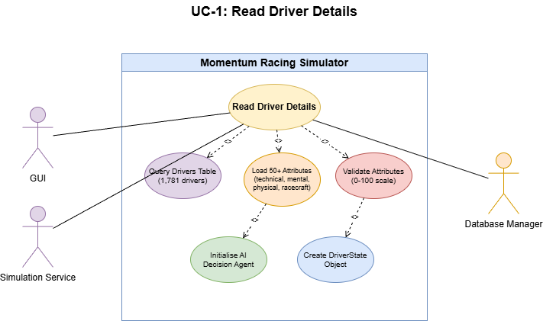

UC-2: Read Race Configuration

Scope
Retrieve track information (175 circuits with IMA grading, surface types, characteristics) and race parameters from the SQLite database to configure the real-time race simulation engine.

Description
The GUI and Simulation Service query track records containing length, surface type, corners, and IMA characteristics. The system loads this data to initialise the track map with 100 evenly-spaced checkpoints, corner types (slow/medium/fast), and DRS zones for the physics engine.

Actors
- GUI - requests track data for race setup and displays circuit information.
- Simulation Service - loads track configuration to initialise the TrackMap and physics calculations.
- Database Manager - queries the tracks table and returns Track objects.

Flow Description

Precondition
Database contains 175 circuit definitions imported from data/circuits_database.json.

Activation
Starts when the GUI loads the race setup screen and requests available tracks, or when the Simulation Service begins a race session.

Main flow
- GUI calls DatabaseManager.get_all_tracks() or get_track(track_id).
- Database Manager executes SELECT query against the tracks table.
- System returns Track objects containing name, length (km), country, surface type, and IMA grading.
- For simulation, the engine generates a TrackMap with corner sections and racing physics parameters.
- The circuit is rendered in the GUI with 100 checkpoint markers at 1% intervals.

Alternate flow
A1: Invalid track_id requested - return None and GUI displays error or fallback message. A2: No tracks available in database - GUI prompts user to run scripts/import_circuits.py to populate track data.

Exceptional flow
E1: Database read error - GUI logs exception to logs/database_generation.log and displays connection error. E2: Missing track characteristics - System uses default values (medium corners, standard grip) and logs warning.

Termination
Caller receives track configuration and proceeds to simulation or display rendering.

Diagram
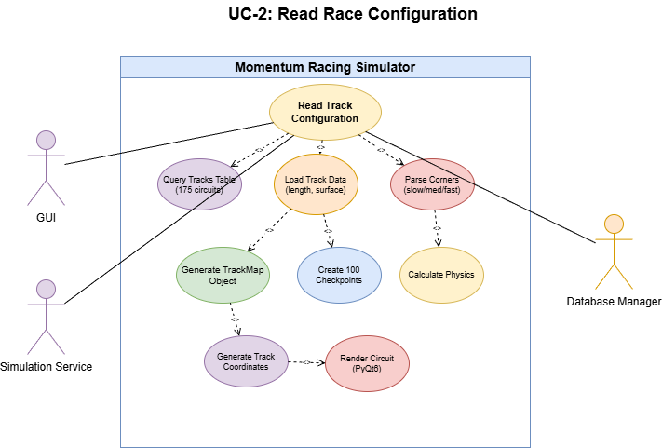

UC-3: Create Race Result

Scope
Persist race outcomes (positions, times, incidents) and trigger standings updates.

Description
Accept a race result payload from the Simulation Service or operator, validate it, persist the results atomically, and enqueue standings recalculation.

Actors
- Simulation Service - submits generated race results.
- Standings Service - recalculates standings from persisted results.

Flow Description

Precondition
Race event exists and is writable.

Activation
Starts when the simulation finishes or an operator submits results.

Main flow
- The Simulation Service submits the result payload.
- The system validates the payload and event state, stores race_results in a transaction, and marks the event complete.
- The system enqueues a standings recalculation job and returns acknowledgement.

Alternate flow
A1: Validation failure - return 400 with field-level errors. A2: Event already finalised - return 409 Conflict and provide adjustment options.

Exceptional flow
E1: Database write failure - return 500 and include diagnostic id.

Termination
Event status updated; standings update job queued.

Diagram
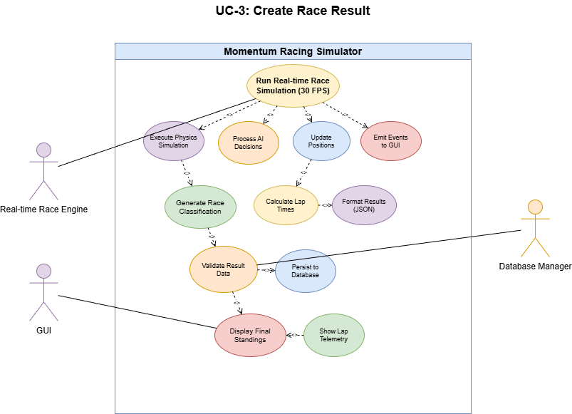

UC-4: Read Race Results

Scope
Retrieve historical race results from the database for display in the GUI, including final classification, lap times, and DNF information.

Description
The system queries completed race records to display historical results. Results include finishing positions, lap times, DNF reasons, and incident details for analysis and comparison.

Actors
- GUI - requests and displays historical race results.
- Database Manager - queries the race_results table and joins with driver/team data.

Flow Description

Precondition
Race results have been persisted to the database from previous simulations.

Activation
Starts when user navigates to race history screen or requests results for a specific event.

Main flow
- GUI calls DatabaseManager.get_race_results(race_id) or get_championship_results(championship_id).
- Database Manager executes SELECT query joining race_results, drivers, and teams tables.
- System returns ordered list of results with driver names, positions, times, and DNF reasons.
- GUI displays results in standings table format.

Alternate flow
A1: No results found for requested race - GUI displays "No results available" message. A2: Partial results due to incomplete race - GUI displays available data and marks as "Race Incomplete".

Exceptional flow
E1: Database read failure - GUI logs error and displays cached results if available from previous session. E2: Corrupt result data - System logs validation errors and displays partial data with warning.

Termination
GUI displays historical results and awaits user navigation.

Use Case Diagram
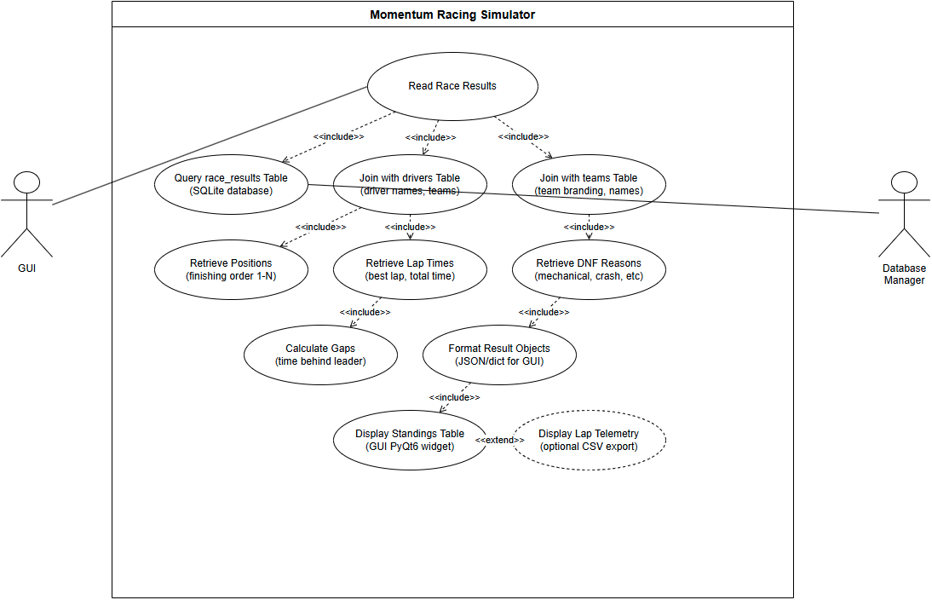

UC-5: Read Championship Details

Scope
Retrieve championship information including season parameters, calendar of events, current standings, and points allocations across 7 racing disciplines.

Description
The system maintains championship records tracking season-long competitions. Each championship contains a calendar of races, points standings, and discipline-specific rules for the simulation.

Actors
- GUI - displays championship standings, calendar, and season progress.
- Game Loop - manages season progression and championship state (planned feature).
- Database Manager - queries championship, standings, and calendar data.

Flow Description

Precondition
Championship has been created with discipline, season year, and initial calendar.

Activation
Starts when user navigates to championship screen or game loop initialises a season.

Main flow
- GUI or Game Loop requests championship data via DatabaseManager.get_championship(championship_id).
- System retrieves championship metadata (discipline, year, points system).
- System queries calendar entries and aggregates standings from race results.
- GUI displays championship overview with standings table and upcoming races.

Alternate flow
A1: Championship has no races yet - display empty calendar with option to schedule events. A2: Standings unavailable - calculate standings from existing race results or display zero points.

Exceptional flow
E1: Database query failure - GUI displays error and offers retry or cached data. E2: Invalid championship structure - System logs diagnostic and prompts database verification.

Termination
GUI displays championship view with standings and calendar; system awaits user interaction.

Use Case Diagram
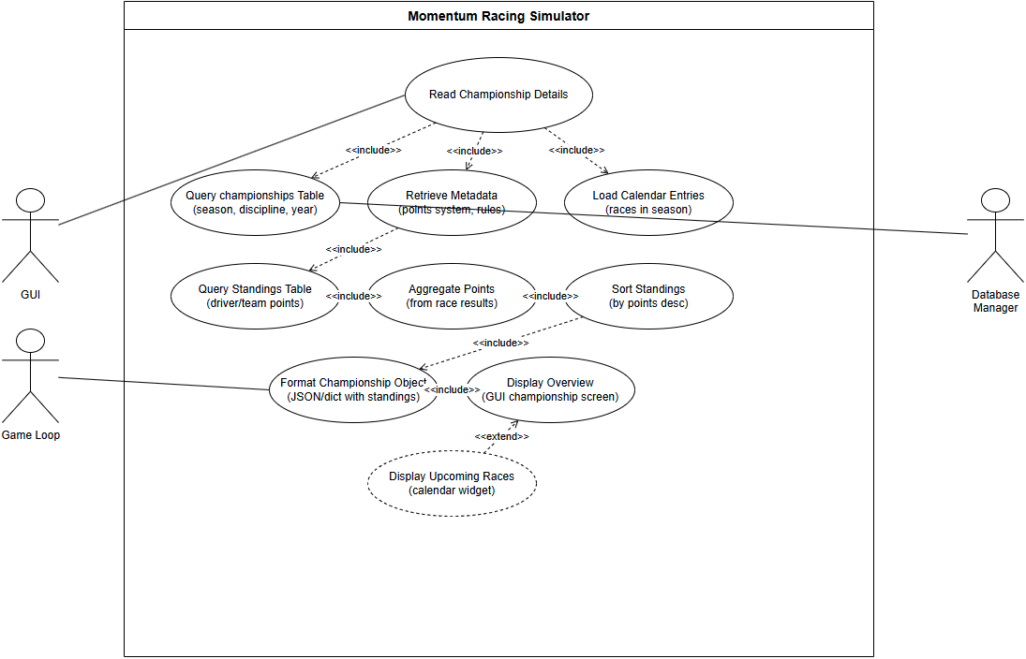

UC-6: Update Championship Standings

Scope
Recalculate and persist championship standings after results are recorded.

Description

Actors
- Standings Service - triggers recalculation and consumes updated standings.
- Admin - may invoke recalculation manually.

Flow Description

Precondition
Championship and results exist.

Activation
Starts when results are created or adjusted.

Main flow
- Gather results for the championship.
- Apply points system and compute standings.
- Persist updated standings and notify consumers.

Alternate flow
A1: Partial update requested - return 202 Accepted with job id for async completion. A2: Concurrent updates - return 409 Conflict with current version.

Exceptional flow
E1: Points rules missing - return 500 and log for admin attention. E2: Persistence error - roll back and queue retry.

Termination
Standings persisted.

Use Case Diagram
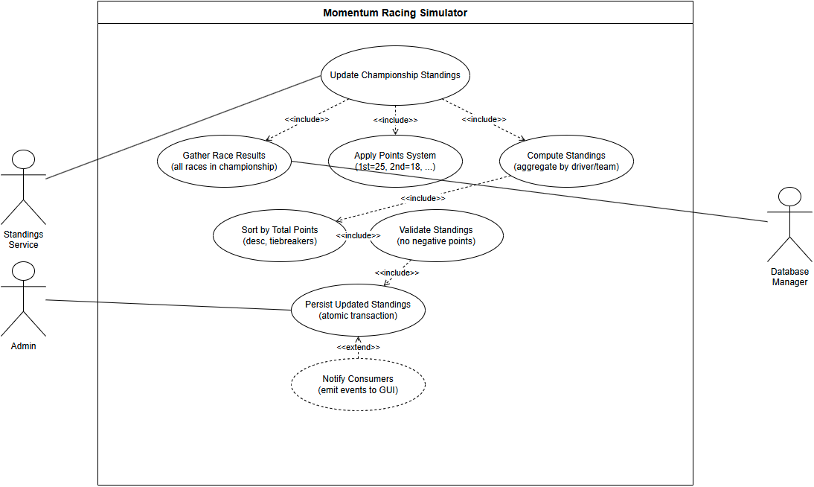

UC-7: Create Race Event

Scope
Add a race event to a championship calendar (track, date, configuration).

Description
An admin or scheduler submits an event; the backend validates and persists the event record.

Actors
- Admin - creates and manages race events.
- Scheduler - schedules events programmatically.

Flow Description

Precondition
Championship exists and is editable.

Activation
Starts when an admin posts new event details.

Main flow
- Validate dates and track availability.
- Insert event record into races.
- Return created resource.

Alternate flow
A1: Date/track conflict - return 409 Conflict with conflicts and alternatives. A2: Validation warning - return 200 with warnings and allow override.

Exceptional flow
E1: Database write failure - return 500 and persist request to retry queue. E2: External sync failure - create event in draft and return 202 Accepted with sync pending.

Termination
Calendar updated; notifications may be sent.

Use Case Diagram
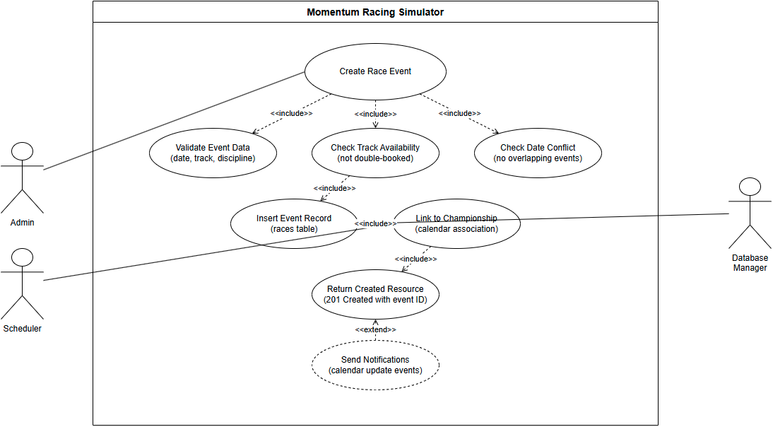

UC-8: Read Race Schedule

Scope
Retrieve championship calendar/schedule for UI display.

Description
Return ordered list of events with dates, tracks and statuses.

Actors
- User / UI - requests the schedule for display.
- Calendar Service - synchronises events externally when configured.

Flow Description

Precondition
Championship or season exists.

Activation
Starts when client opens the calendar screen.

Main flow
- Validate championship/season.
- Retrieve ordered events and metadata.
- Return schedule to caller.

Alternate flow
A1: Championship not found - return 404 Not Found with guidance to create a championship first. A2: Championship exists but has no events - return empty schedule with a message suggesting adding events.

Exceptional flow
E1: Database read error - return 503 Service Unavailable with diagnostic id; offer cached schedule if available. E2: Permission or tenancy error - return 403.

Termination
Client displays schedule.

Post condition
System awaits next request.

Use Case Diagram
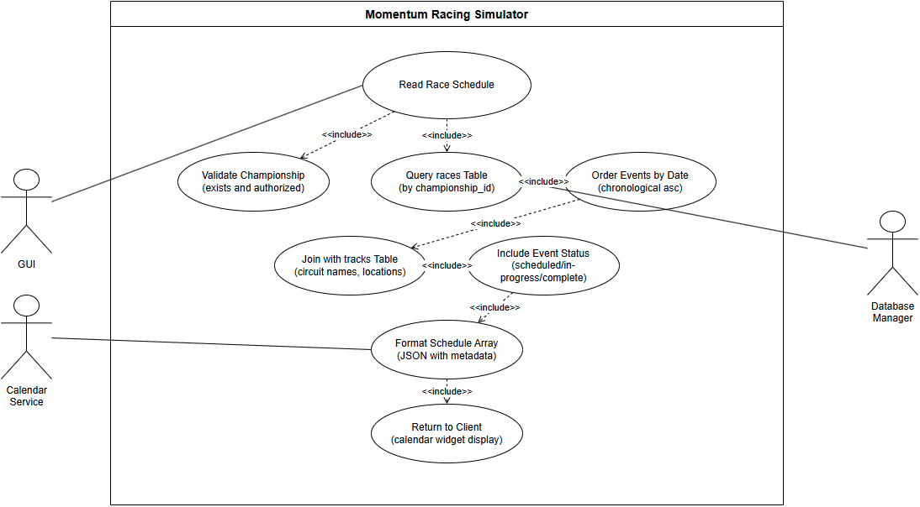

UC-9: Update Race Status

Scope
Change a race event status (scheduled → in-progress → completed → cancelled).

Description
Update event lifecycle state and notify dependent systems.

Actors
- Simulation/Service - updates status during simulation.
- Admin - may manually change status.
- Notification Service - receives lifecycle events.

Flow Description

Precondition
Event exists and caller has permission.

Activation
Starts when a service or admin posts a status update.

Main flow
- Validate transition is allowed.
- Update races.status accordingly.
- Emit notifications/events.

Alternate flow
A1: Invalid lifecycle transition (e.g., completed → scheduled) - return 400 Bad Request with allowed transitions and current state. A2: Caller requests cancellation during in-progress - return 202 Accepted and initiate graceful abort procedures (safety checks, rollback attempts).

Exceptional flow
E1: Database write error or optimistic lock fail - return 500 and include current event state; schedule a background reconciliation job. E2: Notification subsystem failure - update status but record notification failure for later retry; return 200 with notificationsPending: true.

Termination
Event status updated and notifications sent.

Post condition
System awaits next lifecycle event.

Use Case Diagram
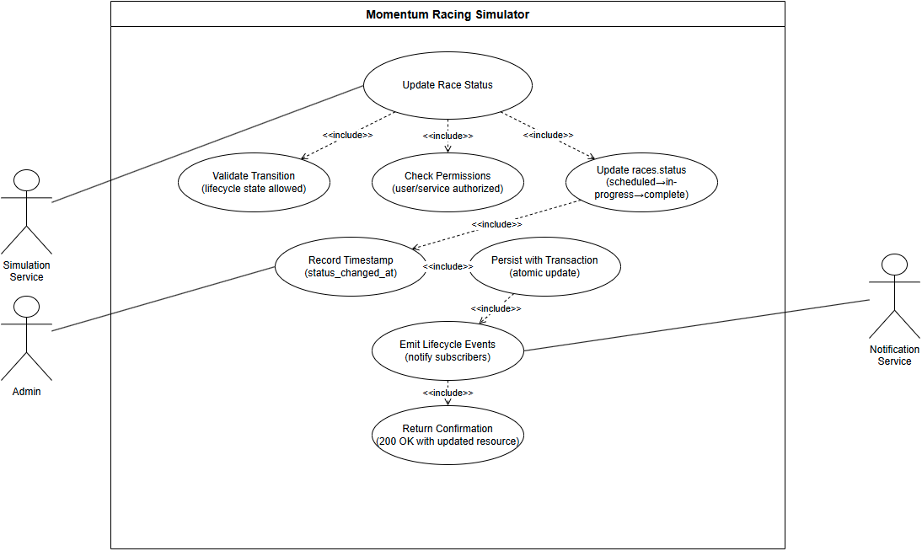

UC-10: Create Championship

Scope
Create a new championship/season automatically on season rollover, with base rules and an empty calendar.

Description
On season rollover the Game Loop computes the next season parameters, instantiates a championship record with a ruleset and calendar placeholder, persists it, and notifies downstream systems (scheduling, AI, UI) that a new season is available.

Actors
- Game Loop / Scheduler - triggers automatic season rollover and championship creation.
- Policy Service - validates or supplies rulesets.
- Event Scheduler - consumes the new championship to populate events.

Flow Description

Precondition
End-of-season tick reached; ruleset templates and calendar seeding configuration are available.

Activation
Triggered automatically by the Game Loop on season rollover (no manual admin intervention required).

Main flow
- Game Loop determines season rollover has occurred and computes seed parameters (year, discipline, ruleset template).
- System requests/validates the ruleset from Policy Service.
- System creates the championship record with initial metadata and an empty calendar.
- System persists the championship atomically and emits events to Event Scheduler, AI and UI.

Alternate flow
A1: Ruleset validation fails - select fallback template and continue, or mark championship as requiresReview and emit admin notification.

Exceptional flow
E1: Database write failure - rollback and schedule a retry; emit diagnostic id to monitoring and place a recovery job in the maintenance queue.

Termination
Championship record created and downstream systems notified.

Post condition
Event Scheduler and AI begin populating events and participants for the new season.

Use Case Diagram
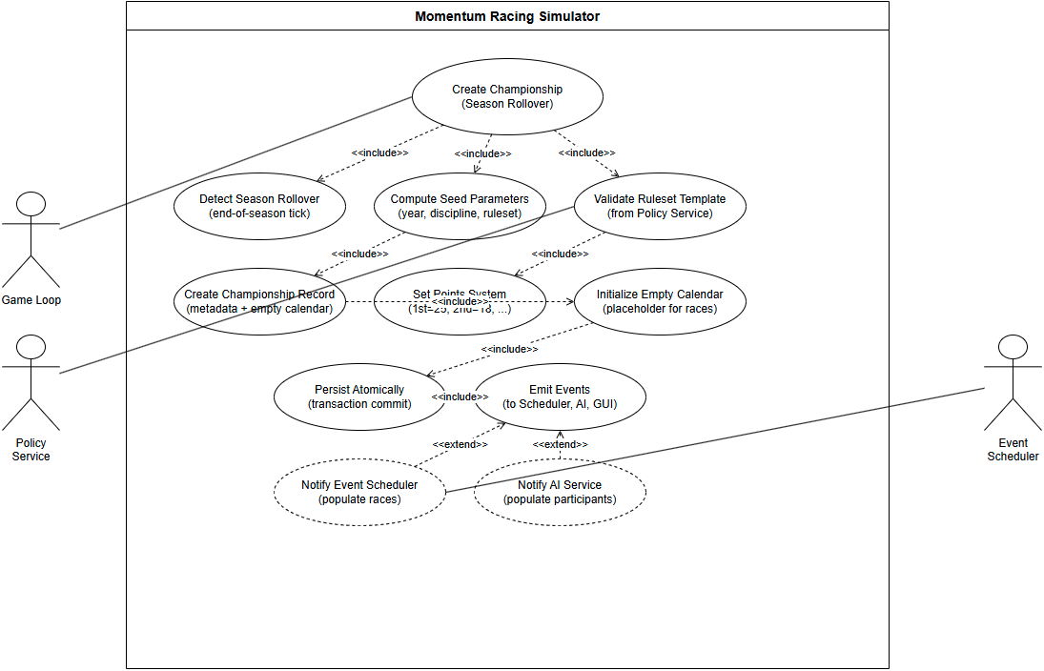

UC-11: Read Team Details

Scope
Retrieve complete team profile including budget (€130M cap for top-tier Single Seater), tier classification, headquarters, discipline specialisation, and assigned drivers.

Description
The system maintains 1,095 team records across 7 racing disciplines. Each team has budget constraints, tier classification (tier1/tier2/tier3), and performance multipliers that affect simulation outcomes.

Actors
- GUI - displays team information on management screens.
- Simulation Service - requests team data to calculate performance multipliers for race simulation.
- Database Manager - queries the teams table and joins with driver assignments.

Flow Description

Precondition
Team records exist in database with complete attribute sets.

Activation
Starts when GUI loads team management screen or simulation engine initialises a race.

Main flow
- GUI or Simulation Service calls DatabaseManager.get_team(team_id) or get_teams_by_discipline(discipline).
- Database Manager executes SELECT query against teams table.
- System retrieves team metadata including budget, tier, headquarters, and discipline.
- For simulation, engine calculates team performance multiplier (0.55 to 0.95) based on tier and budget.
- GUI displays team profile or simulation applies multipliers to driver performance.

Alternate flow
A1: Invalid team_id - return None and GUI displays "Team not found" error. A2: Team has no assigned drivers - display team info with empty roster.

Exceptional flow
E1: Database read failure - GUI logs error to logs/ and displays connection error with retry option. E2: Missing team attributes - System uses default values (tier2, €100M budget) and logs warning.

Termination
GUI displays team screen or simulation proceeds with team performance calculations.

Post condition
System awaits next team query or user action.

Use Case Diagram
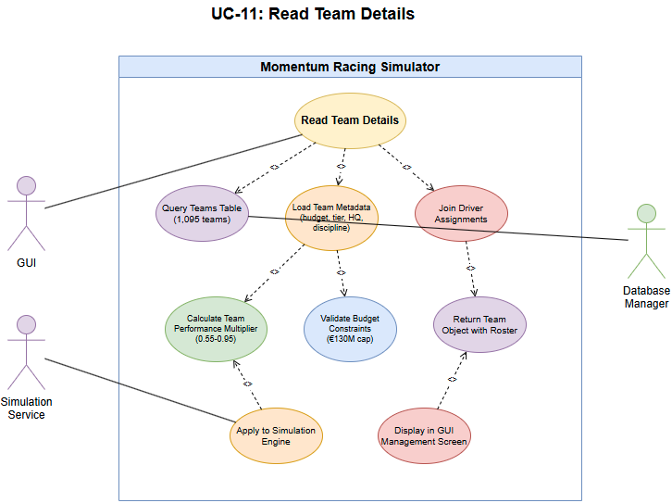

UC-12: Create New Team

Scope
Create a new team record (initial roster, budget, HQ).

Description
Player or admin creates a team; the system allocates starting assets or placeholders.

Actors
- Player/Admin - initiates team creation.
- Provisioning Service - reserves starting resources.

Flow Description

Precondition
Requester authorised; required seed data available.

Activation
Starts when player/admin submits team creation.

Main flow
- Validate request and reserve resources.
- Insert team record and assign initial roster/placeholders.
- Return created team.

Alternate flow
A1: Resource conflict (e.g., team name or HQ occupied) - return 409 Conflict with suggested alternatives and actions to resolve. A2: Missing seed data - return 422 Unprocessable Entity with details on required fields.

Exceptional flow
E1: Database transaction failure - return 500 and log the full request for replay. E2: External provisioning failure (e.g., storage) - create the team in pending state and notify admin.

Termination
Team visible in lists.

Post condition
System awaits next management action.

Use Case Diagram
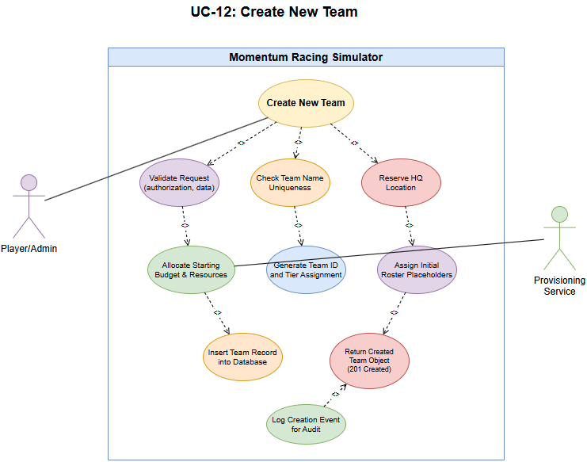

UC-13: Read Team Details (player team)

Scope
Return player's own team with editable flags and affordances.

Description
Provide editable team data for the player's management screen.

Actors
- Player - owner of the team and primary editor.
- Auth Service - validates ownership and permissions.

Flow Description

Precondition
Player has a team.

Activation
Starts when player opens their team management screen.

Main flow
- Validate player's identity and team ownership.
- Return team data with editable flags.

Alternate flow
A1: Player has no team - return 404 Not Found with guidance to create or join a team and links to relevant endpoints.

Exceptional flow
E1: Database read error - return 503 Service Unavailable and include a diagnostic id. E2: Authorization check failure - return 403.

Termination
Player views editable team screen.

Post condition
System awaits further edits.

Use Case Diagram
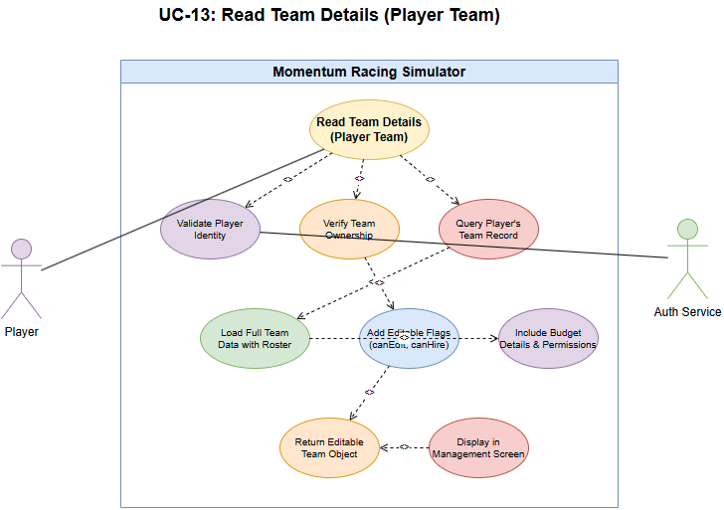

UC-14: Update Team Attributes

Scope
Modify team attributes (budget allocation, HQ upgrades, staff assignments).

Description
Player or admin updates team settings which are validated and persisted.

Actors
- Player/Admin - submits updates.
- Finance Service - validates budget changes.

Flow Description

Precondition
Requester authorised and has sufficient resources.

Activation
Starts when client submits team updates.

Main flow
- Validate changes and budget.
- Persist updates.
- Return updated resource.

Alternate flow
A1: Insufficient funds detected - return 422 Unprocessable Entity with required amount and suggestions (sponsor, loan, reduce spend). A2: Concurrent update to budget - return 409 Conflict with current balance and retry instructions.

Exceptional flow
E1: Database write/commit failure - return 500 and enqueue the update for manual reconciliation. E2: Audit/logging service failure - persist the change but flag audit missing; return 200 with auditPending: true.

Termination
Changes reflected on subsequent reads.

Post condition
System awaits next request.

Use Case Diagram
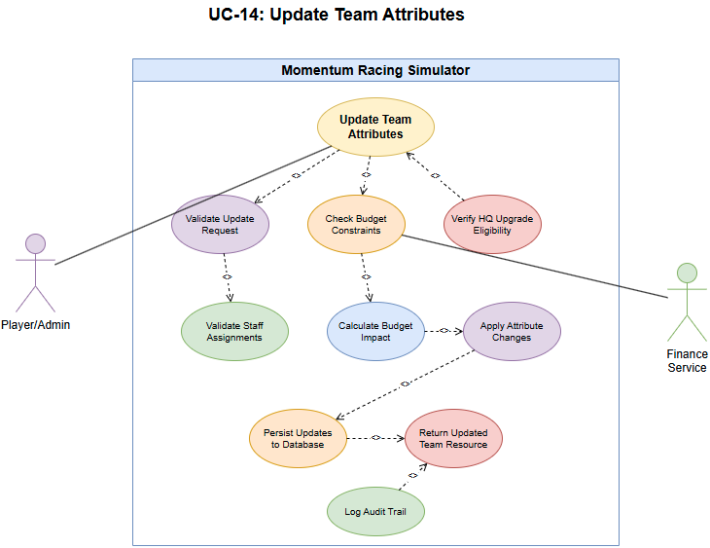

UC-15: Read Available Drivers

Scope
Return list of uncontracted or transfer-available drivers for recruitment.

Description
Provide filtered and paginated driver pool for the market UI.

Actors
- Player - browses and filters available drivers.
- Team AI - automated consumer of driver listings.

Flow Description

Precondition
Driver pool exists.

Activation
Starts when user opens driver market.

Main flow
- Apply filters/pagination.
- Return driver list with availability flags.

Alternate flow
A1: Filter parameters return no matches - return 200 OK with empty list and suggestions to relax filters. A2: Partial data due to pagination limits - include hasMore: true and next-page token.

Exceptional flow
E1: Database query failure - return 503 Service Unavailable with diagnostic id; if cached pool exists return cached results marked stale: true. E2: Indexing/search service failure - fall back to simple DB query and note reduced fidelity.

Termination
Client displays candidate drivers.

Post condition
System awaits next query.

Use Case Diagram
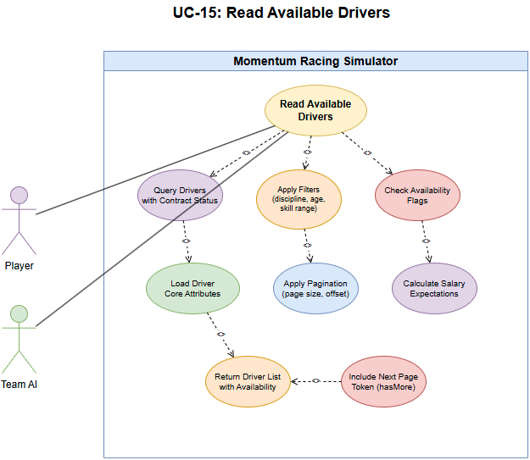

UC-16: Update Driver Contract

Scope
Sign, renew or terminate driver contracts and update team roster and budget.

Description
Persist contract terms and adjust availability and team budgets.

Actors
- Team Manager - negotiates and confirms driver contracts.
- Admin - enforces or modifies contract rules when required.

Flow Description

Precondition
Driver and team exist; negotiation outcome determined.

Activation
Starts when contract terms are finalised and submitted.

Main flow
- Validate budget and contract rules.
- Persist contract and update roster/budget.
- Return confirmation.

Alternate flow
A1: Budget shortfall during contract update - return 422 with required funding and options (defer, partial contract, renegotiate). A2: Contract already signed by another party - return 409 Conflict with current contract details.

Exceptional flow
E1: Database write error - rollback, return 500 and include reference id for support. E2: Payment gateway or external finance service failure - abort contract update, return 502 Bad Gateway and queue retry.

Termination
Driver assigned and availability updated.

Post condition
System awaits next contract action.

Use Case Diagram
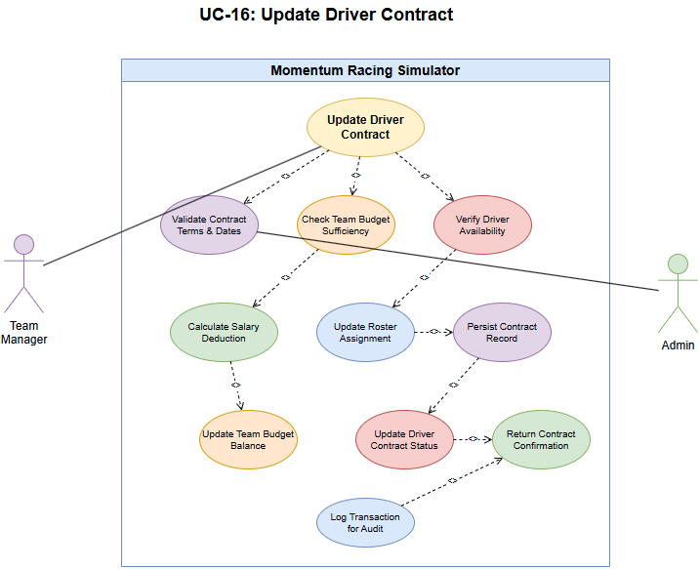

UC-17: Read Available Staff

Scope
Return list of available staff for hiring with roles and modifiers.

Description
Provide paginated staff pool for recruitment screens.

Actors
- Player - requests staff listings.
- HR Service - provides staff filters and pools.

Flow Description

Precondition
Staff pool exists.

Activation
Starts when player opens staff hiring screen.

Main flow
- Apply filters and paginate.
- Return staff list with core stats and cost.

Alternate flow
A1: No staff matching filters - return 200 OK with empty list and filter suggestions. A2: Partial availability (some staff on contract) - return available subset with availability: limited flag.

Exceptional flow
E1: Database or search index failure - return 503 Service Unavailable and provide cached results if available. E2: Data corruption in staff records detected - return 500 and set a maintenance flag.

Termination
Client displays staff candidates.

Post condition
System awaits next request.

Use Case Diagram
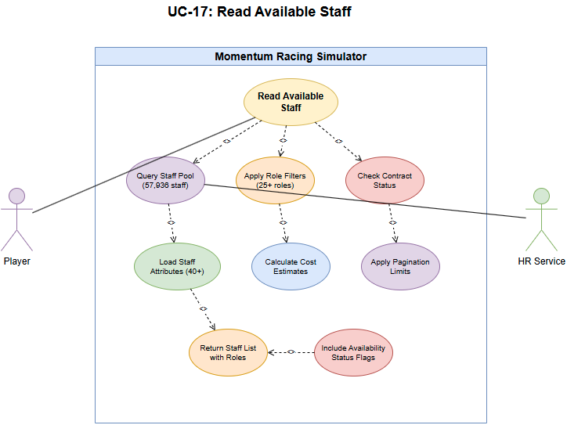

UC-18: Update Staff Contract

Scope
Hire, fire or renegotiate staff contracts and persist changes to team resources.

Description
Assign staff to teams, record salary and update budgets.

Actors
- Player - initiates hiring/renegotiation.
- Team Manager - manages staff assignments.

Flow Description

Precondition
Staff profile exists and is available.

Activation
Starts when hiring/renegotiation action is confirmed.

Main flow
- Validate terms and budget.
- Persist contract and update team state.
- Return confirmation.

Alternate flow
A1: Insufficient funds - return 422 Unprocessable Entity with required funding detail and rollback any provisional assignments. A2: Candidate no longer available at confirmation - return 409 Conflict and provide alternatives.

Exceptional flow
E1: Database write failure - rollback and return 500 with support reference. E2: Concurrent contract update detected - return 409 with current contract state and instructions to retry.

Termination
Staff assigned and salary deducted from budget.

Post condition
System awaits further HR actions.

Use Case Diagram
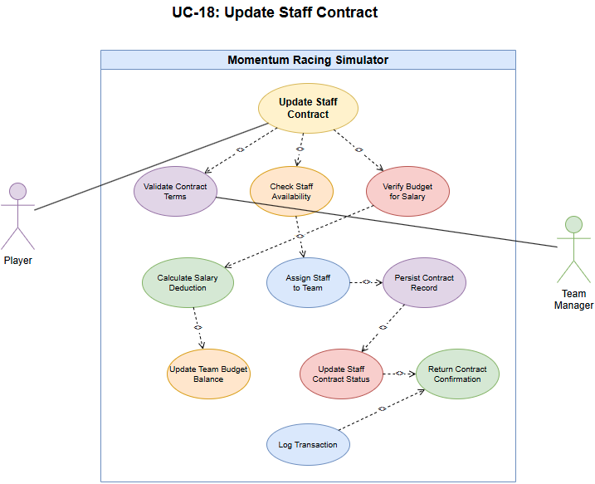

UC-19: Update Driver Skills/Age

Scope
Periodic update of driver attributes (ageing, progression/regression) and handle retirements/recycling.

Description
Perform end-of-season or scheduled updates to driver skills and ages; mark retirees and optionally regenerate/recycle entities.

Actors
- Scheduler (Game Loop) - triggers seasonal maintenance jobs.
- Admin - may invoke manual progression runs.

Flow Description

Precondition
Driver population present.

Activation
Starts at season end or scheduled tick.

Main flow
- System iterates drivers and adjusts skills and ages.
- Flag retired drivers and recycle or replace per policy.
- Persist updates.

Alternate flow
A1: Emergency update due to injury or incident - apply immediate decrement to affected driver(s), mark as underReview, and notify teams. A2: Player-triggered training boost - apply progression rules and mark a cooldown period.

Exceptional flow
E1: Batch update failure during season tick - return 500, log affected driver ids and schedule a retry job. E2: Constraint violation (e.g., negative attribute) - abort update for affected records and flag for manual review.

Termination
Driver records updated for next season.

Post condition
System awaits next scheduled update.

Use Case Diagram
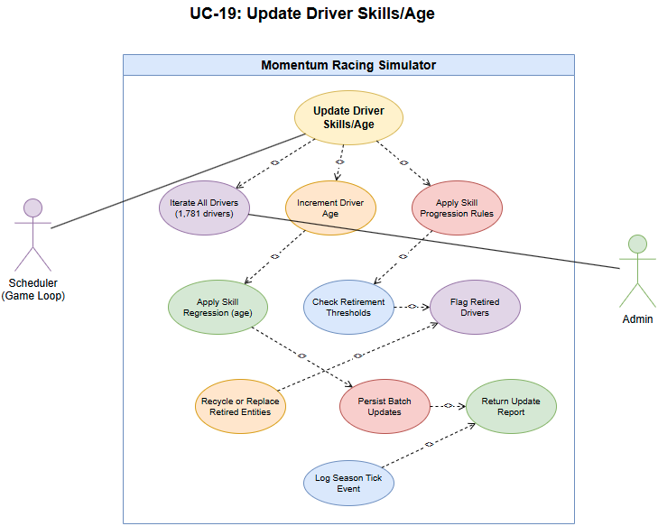

UC-20: Update Team Budget

Scope
Adjust team budget for income/expenses, sponsor payouts and race fees.

Description
Apply transactions affecting a team's budget and persist them.

Actors
- Finance System - posts transactions affecting team budgets.
- Game Loop - triggers periodic income/expense events.

Flow Description

Precondition
Team exists.

Activation
Starts when a transaction affecting budget occurs.

Main flow
- Validate transaction and atomicity.
- Update team budget.
- Return updated balance.

Alternate flow
A1: Insufficient funds for debit - reject the transaction with 402 Payment Required (or 422) and suggest corrective actions (sponsor, loan, adjust expenses). A2: Pending transactions that affect available balance - return 409 Conflict with pending transaction list.

Exceptional flow
E1: Database write failure - return 500 and enqueue transaction for replay.

Termination
Team budget updated and awaiting next transaction.

Use Case Diagram
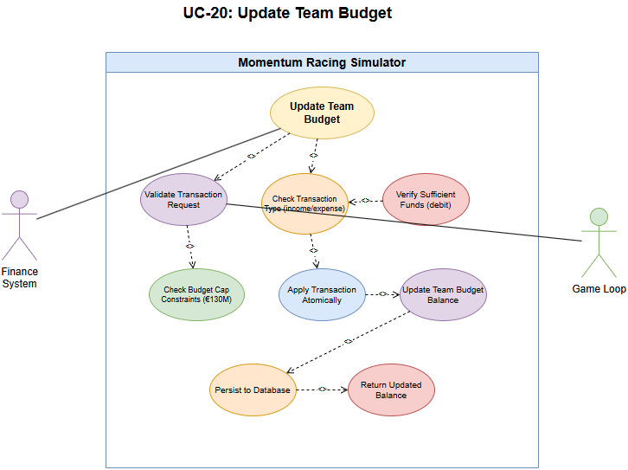

UC-21: Create New Driver

Scope
Add a driver to the hireable pool by recycling an existing placeholder or generating a new driver profile when pool thresholds require expansion.

Description
Maintain and expand the hireable driver pool to support roster growth, replacement of retired drivers, and content variety. The system prefers recycling deactivated driver records when suitable; otherwise the Generator Service creates a new driver profile validated against uniqueness and configured policy constraints.

Actors
- Admin - requests manual creation.
- System - scheduled or policy-driven generator.
- Generator Service - produces seeded attribute payloads for new drivers.

Flow Description

Precondition
Driver pool is below configured threshold or an explicit admin request to create a driver is received; seeding and generation configuration are available.

Activation
Triggered by POST /api/drivers/generate from an admin or by an automated roster expansion job.

Main flow
- Validate request and policy constraints (pool thresholds, allowed classes).
- Attempt to select a recycle candidate from the deactivated pool; if none available, call Generator Service to create attributes.
- Validate generated attributes (unique name, valid age, discipline suitability).
- Persist the driver record inside a transaction and mark availability.
- Return 201 Created with the driver resource.

Alternate flow
A1: Recycle candidate unavailable - generate new attributes and continue. A2: Minor validation warnings - persist with a warnings field and return 201 Created. A3: Name or identity conflict - mutate the attribute (rename) and retry up to configured attempts; on exhaustion return 409 Conflict with guidance.

Exceptional flow
E1: Database write failure - rollback and return 500 with diagnostic id for support. E2: Generator Service unavailable - return 503 Service Unavailable and schedule a retry job. E3: Policy or configuration violation - return 422 Unprocessable Entity with policy details.

Termination
Driver record created and visible in the hireable pool.

Post condition
Driver returned in subsequent listing endpoints and system awaits next generation task.

Use Case Diagram
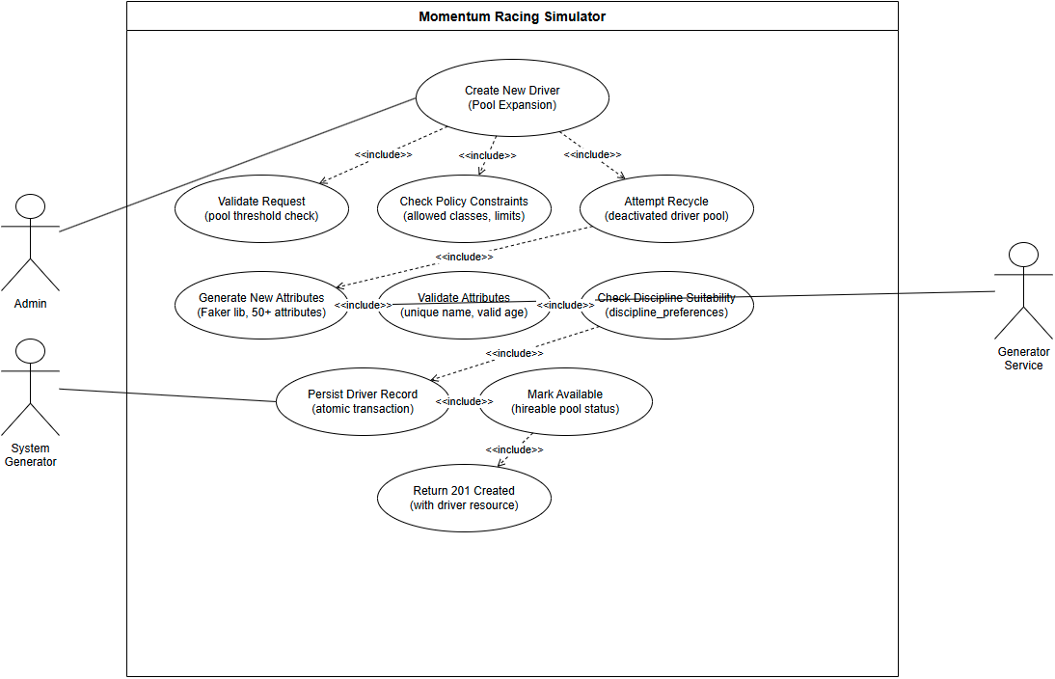

UC-22: Create New Staff Member (staff generation)

Scope
Generate new staff when required (optional).

Description
Create or recycle staff records for hireable pool expansion.

Actors
- Admin/System - triggers staff generation or pool maintenance.

Flow Description

Precondition
Staff pool needs expansion.

Activation
Triggered by admin or scheduled regeneration.

Main flow
- Generate staff attributes and persist.
- Return created staff record.

Alternate flow
A1: Attribute conflict or duplicate identity - alter generated attributes (name, hometown) and retry generation automatically. A2: Pool constraints prevent generation - return 422 with explanation (e.g., max drivers reached).

Exceptional flow
E1: Database write failure - return 500 and record the attempted generation for retry. E2: Resource exhaustion (temp files, quota) - return 503 and back off generation.

Termination
Staff visible in hiring pool.

Post condition
System awaits next generation.

Use Case Diagram
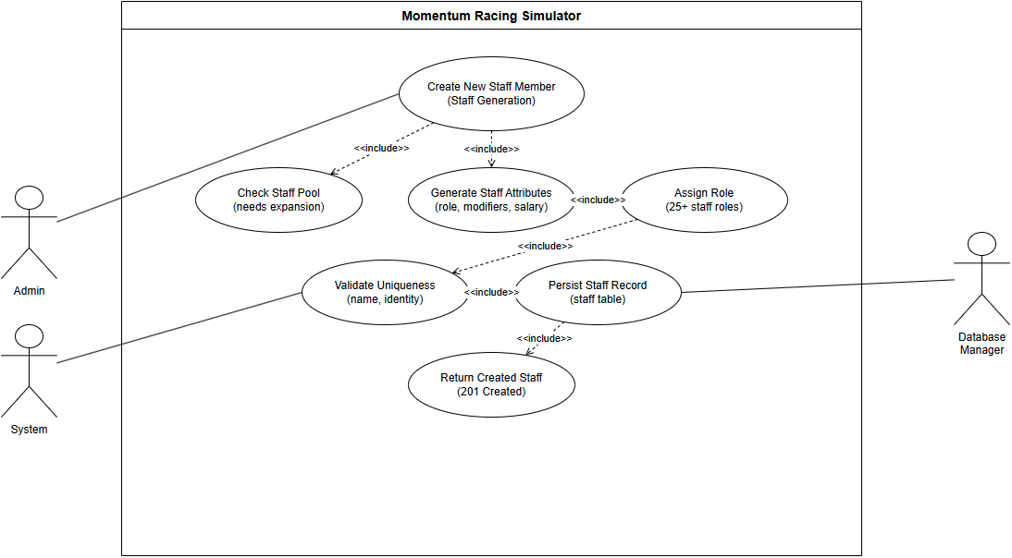

UC-23: Delete Championship

Scope
Remove or archive a championship (admin only).

Description
Delete or archive championship and related resources according to retention policy.

Actors
- Admin - authorised to delete or archive championships.

Flow Description

Precondition
Admin authorised and backup policy confirmed.

Activation
Starts when admin confirms deletion.

Main flow
- Perform integrity checks.
- Delete or archive resources.
- Return confirmation.

Alternate flow
A1: Referential integrity prevents deletion - return 409 Conflict with list of dependent resources and suggested cleanup steps. A2: Admin chooses archive instead of delete - archive resources and return 200 OK with archived: true flag.

Exceptional flow
E1: Database cascade failure - return 500 and halt operation; create a rollback plan and notify admin. E2: Backup/restore service failure during deletion - abort and recommend manual intervention.

Termination
Championship removed or archived.

Post condition
System awaits next admin action.

Use Case Diagram
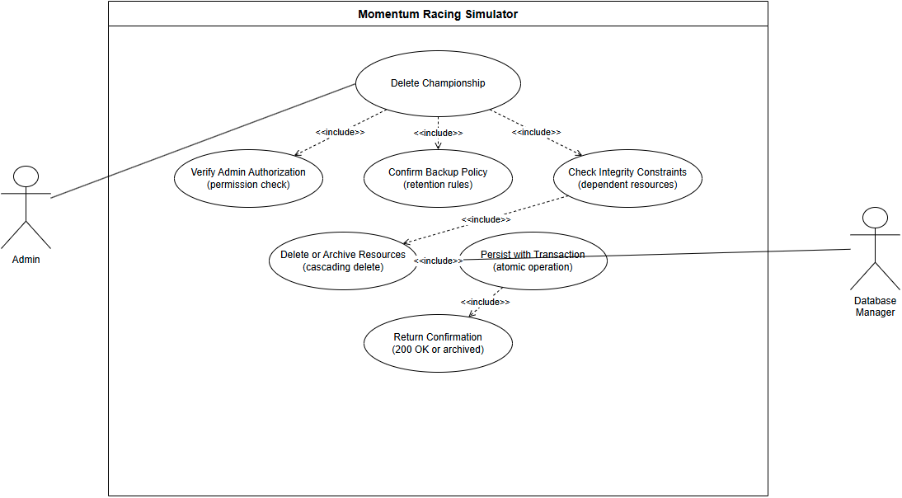

UC-24: Create Custom Track

Scope
Add a custom track with characteristics for use in events.

Description
Designer or admin submits track metadata and layout which becomes available for events.

Actors
- Designer/Admin - submits track definitions and layout files.

Flow Description

Precondition
Creator authorised.

Activation
Starts when track creation form is submitted.

Main flow
- Validate track data.
- Insert track record.
- Return created track resource.

Alternate flow
A1: Invalid or incomplete track layout submitted - return 400 Bad Request with field-level errors and validation hints. A2: Duplicate track name or coordinates - return 409 Conflict with resolution options.

Exceptional flow
E1: Database write failure - return 500 and log the payload for manual replay. E2: Geometry parsing failure - return 422 Unprocessable Entity with parsing error details.

Termination
Track available for event creation.

Post condition
System awaits next track management action.

Use Case Diagram
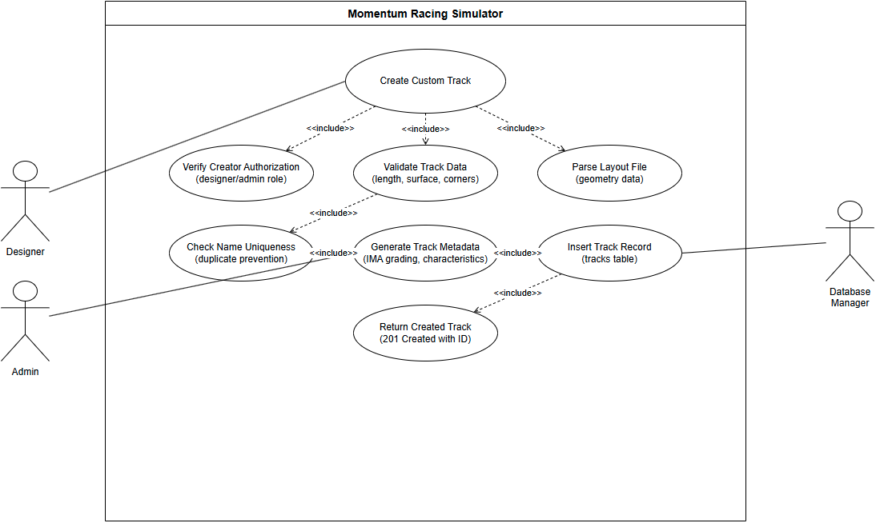

UC-25: Update Track Characteristics

Scope
Modify track parameters (surface, length, grip) for balancing.

Description
Admin updates track metadata and future events use revised parameters.

Actors
- Admin - submits track updates.

Flow Description

Precondition
Track exists and is editable.

Activation
Starts when admin submits updates.

Main flow
- Validate and persist updates.
- Return updated resource.

Alternate flow
A1: Track is scheduled in upcoming events - return 409 Conflict and offer archive or force options with explicit confirmation. A2: Minor characteristic change allowed - apply change with warnings indicating affected events.

Exceptional flow
E1: Database write failure - return 500 and queue the request for admin review. E2: Constraint violation due to dependent events - return 409 and detail the blocking events.

Termination
Track updated for future events.

Post condition
System awaits next management action.

Use Case Diagram
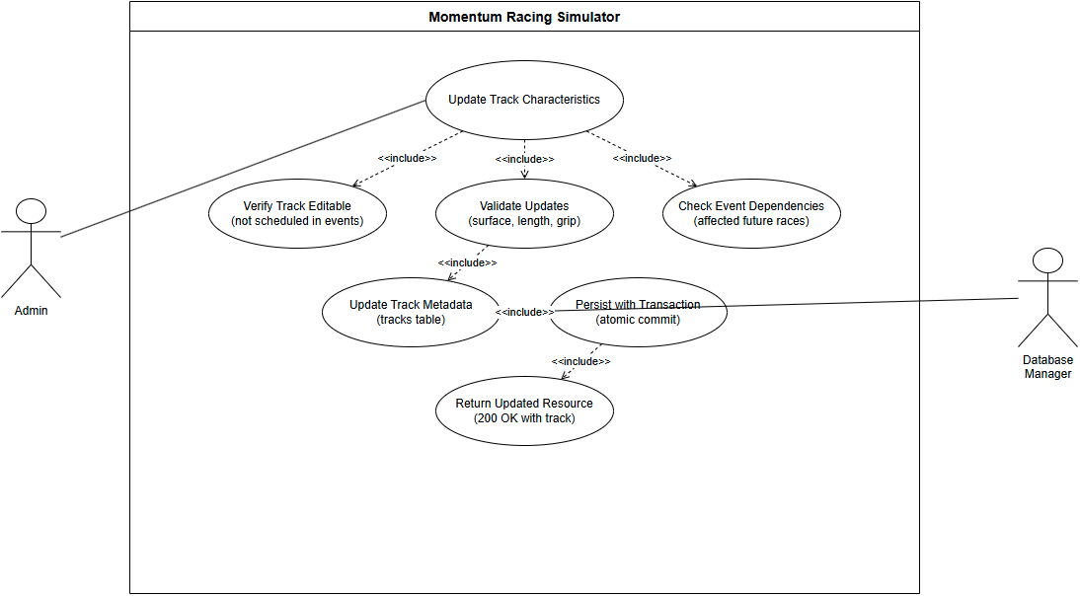

UC-26: Delete Track

Scope
Remove custom or unused tracks with checks for scheduled use.

Description
Admin removes track or archives it if scheduled in future.

Actors
- Admin - initiates deletion or archiving of tracks.

Flow Description

Precondition
Admin confirmed deletion policy.

Activation
Starts when deletion requested.

Main flow
- Check for scheduled events.
- If none, delete; else archive or return 409.

Alternate flow
A1: Track has scheduled events - automatically archive and return 200 OK with archived: true when admin confirms, or return 409 if admin cancels.

Exceptional flow
E1: DB transaction failure during delete/archive - return 500 and log for manual reconciliation. E2: File storage deletion error (assets) - mark record archived and flag cleanup pending.

Termination
Track removed or archived.

Post condition
System awaits further track management.

Use Case Diagram
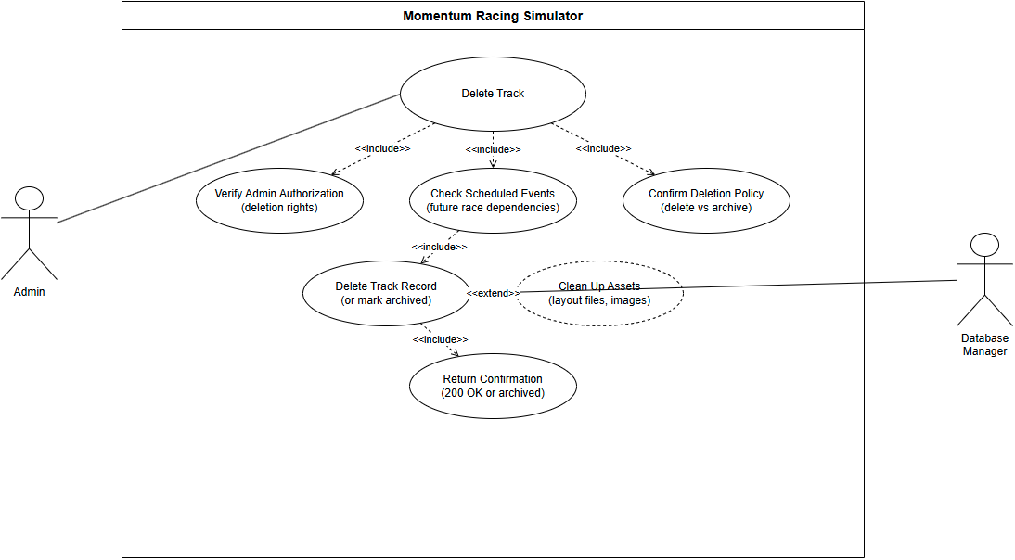

UC-27: Read Staff Performance Modifiers

Scope
Return computed staff modifiers used by the simulation for team performance.

Description
Provide staff-based modifiers (mechanic efficiency, strategist value) to the Simulation Service.

Actors
- Simulation Service - requests computed modifiers for a team.

Flow Description

Precondition
Staff members assigned or available.

Activation
Starts when simulation requests modifiers for a team.

Main flow
- Aggregate staff attributes for team.
- Return modifier set to simulator.

Alternate flow
A1: Missing or partial staff assignments - return default modifiers and mark incomplete: true in response. A2: Requested team has no staff assigned - return 200 OK with defaults and a recommendation to hire staff for full modifiers.

Exceptional flow
E1: Database read failure - return 503 Service Unavailable and include diagnostic id. E2: Aggregation error while computing modifiers - return 500 and provide fallback default values.

Termination
Simulation applies modifiers.

Post condition
System awaits next modifier request.

Use Case Diagram
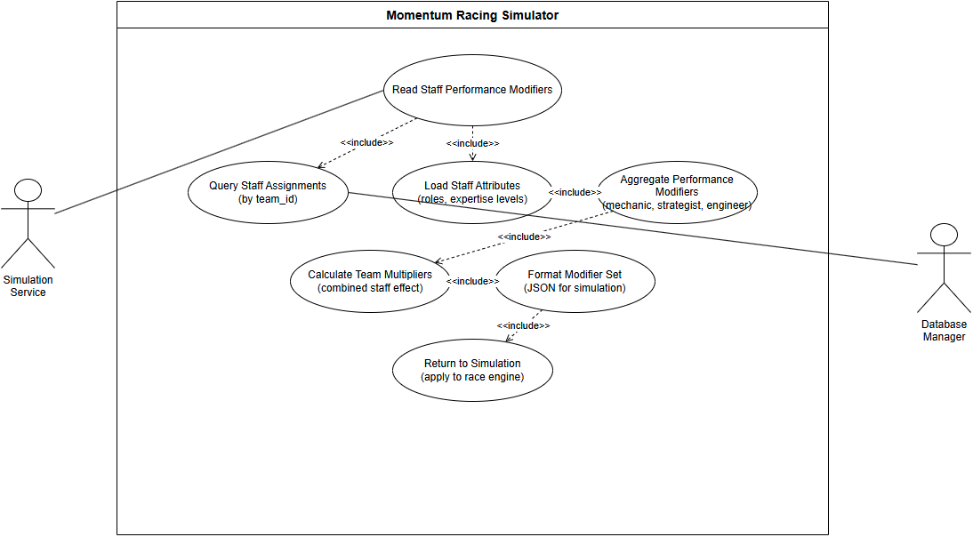

UC-28: Update Driver Appearance

Scope
Change cosmetic appearance for a driver (helmet, livery) - non-gameplay affecting.

Description
Player edits and saves driver appearance assets which are stored and served to UI.

Actors
- Player - creates or edits appearance assets.
- Storage Service - stores and serves asset files.

Flow Description

Precondition
Player owns or is authorised to edit driver appearance.

Activation
Starts when player submits appearance changes.

Main flow
- Validate assets.
- Persist appearance metadata and files.
- Return confirmation.

Alternate flow
A1: Invalid asset format or too large - return 400 Bad Request with accepted formats and size limits. A2: Asset conflicts (same filename) - return 409 Conflict and provide renaming options.

Exceptional flow
E1: File storage error (S3/local) - return 500 and queue asset upload for retry; return a reference id to the client. E2: Virus/validation rejection - return 422 Unprocessable Entity with reason.

Termination
Appearance updated for reads.

Post condition
System awaits further edits.

Use Case Diagram
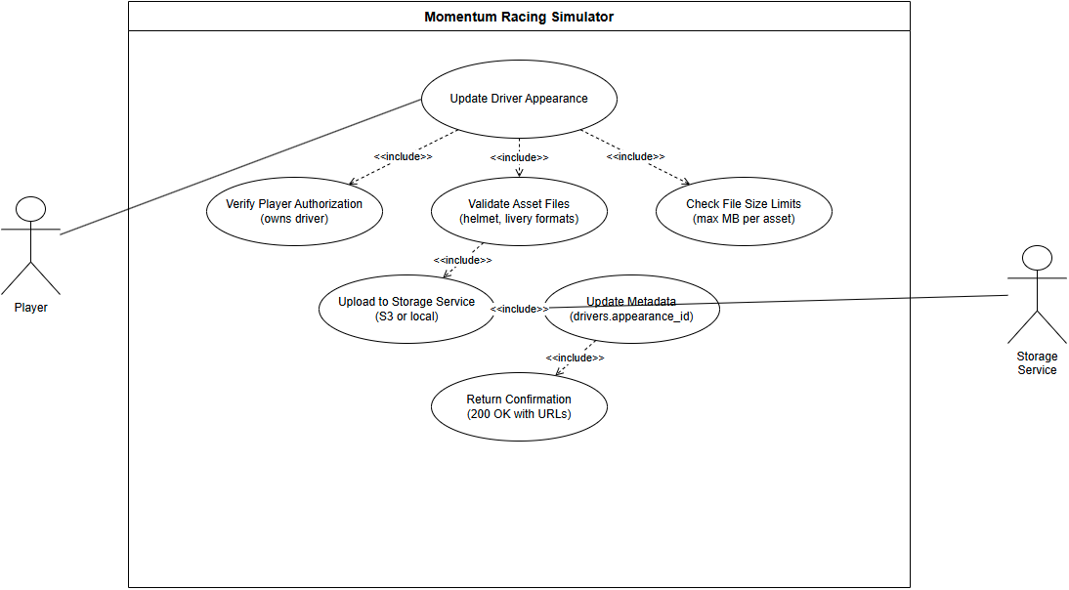

UC-29: Update Team Branding

Scope
Update team visual branding assets and metadata (logos, colours).

Description
Player or admin uploads branding assets and updates team metadata for display in UI.

Actors
- Player/Admin - uploads branding assets.
- Storage/DB - stores branding files and metadata.

Flow Description

Precondition
Requester authorised; assets valid.

Activation
Starts when branding upload is submitted.

Main flow
- Validate assets and metadata.
- Persist files and update team record.
- Return confirmation.

Alternate flow
A1: Invalid branding assets - return 400 Bad Request with clear validation errors and accepted file types. A2: Asset name conflicts - return 409 Conflict with suggested renames.

Exceptional flow
E1: File store or DB failure - return 500 and persist metadata change to a pending queue. E2: Permission or quota error - return 403 or 429 as appropriate with remediation steps.

Termination
Branding served to UI.

Post condition
System awaits next update.

Use Case Diagram
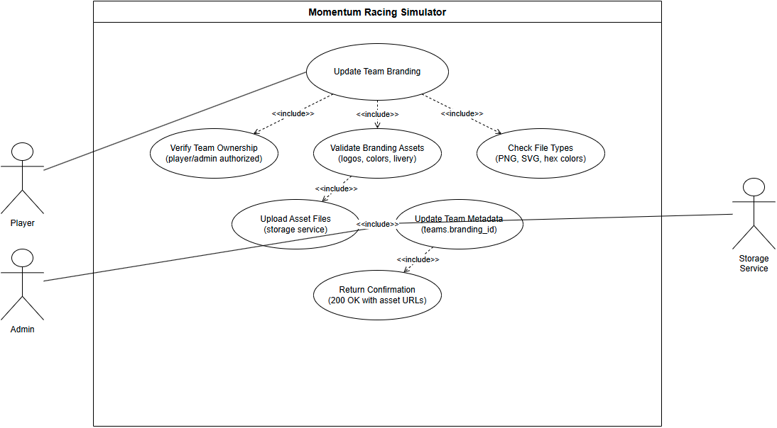

Data Requirements
Database Schema:
The system requires persistent storage for the following entities:
- Drivers Table
  - Primary Key: driver_id (INTEGER)
  - 50+ attribute columns (REAL, 0.0-100.0 range)
  - Biographical data: name, nationality, birth_date, age
  - Career statistics: races, wins, podiums, championships
  - Constraints: CHECK constraints on attribute ranges
- Teams Table
  - Primary Key: team_id (INTEGER)
  - Budget (REAL), discipline (TEXT), tier (INTEGER)
  - Performance attributes: innovation, risk_appetite, management_quality
  - Career statistics: championships, total_wins
- Staff Table
  - Primary Key: staff_id (INTEGER)
  - Foreign Key: team_id references Teams
  - 40+ attribute columns for role-specific skills
  - Contract data: salary, contract_end_date, job_satisfaction
- Tracks Table
  - Primary Key: track_id (INTEGER)
  - Physical characteristics: length, corners, elevation_change
  - Surface data: surface_type, grip_level
  - Challenge ratings: technical_challenge, overtaking_difficulty
- Championships Table
  - Primary Key: championship_id (INTEGER)
  - Series configuration: discipline, points_system, race_count
- Races Table
  - Primary Key: race_id (INTEGER)
  - Foreign Keys: championship_id, track_id
  - Conditions: weather, temperature, track_condition
- RaceResults Table
  - Primary Key: result_id (INTEGER)
  - Foreign Keys: race_id, driver_id, team_id
  - Performance data: position, fastest_lap, points_earned
Data Integrity:
- Foreign key constraints enforce referential integrity
- CHECK constraints validate attribute ranges
- UNIQUE constraints prevent duplicate entries
- NOT NULL constraints on critical fields
Performance Optimisation:
- Indexes on frequently queried fields (driver_id, team_id)
- Composite indexes on race lookups (championship_id, race_id)
- Query optimisation for large result sets

User Requirements

Environmental Requirements
Hardware Requirements:
- Minimum: 2GB RAM, 500MB disk space, 1GHz dual-core CPU
- Recommended: 4GB RAM, 1GB disk space, 2GHz quad-core CPU
Software Requirements:
- Operating System: Windows 10+, macOS 10.14+, Linux (Ubuntu 20.04+)
- Python: Version 3.8 or higher
- Database: SQLite 3.7+
- Network: Internet connection for currency exchange rates (optional)
Deployment Requirements:
- Development: Local uvicorn server on localhost:8000
- Production: ASGI-compatible server (uvicorn, gunicorn)
- Database: File-based SQLite (momentum.db)
- API Keys: Optional for external services (currency rates)
Scalability Considerations:
- API can run multiple worker processes
- Database can migrate to PostgreSQL/MySQL for multi-user scenarios
- Stateless design enables horizontal scaling

Usability Requirements

Design & Architecture

System Architecture Overview

Implementation
Describe the main algorithms/classes/functions used in the code. Consider to show and explain interesting code snippets where appropriate.

Graphical User Interface (GUI)
Main Menu
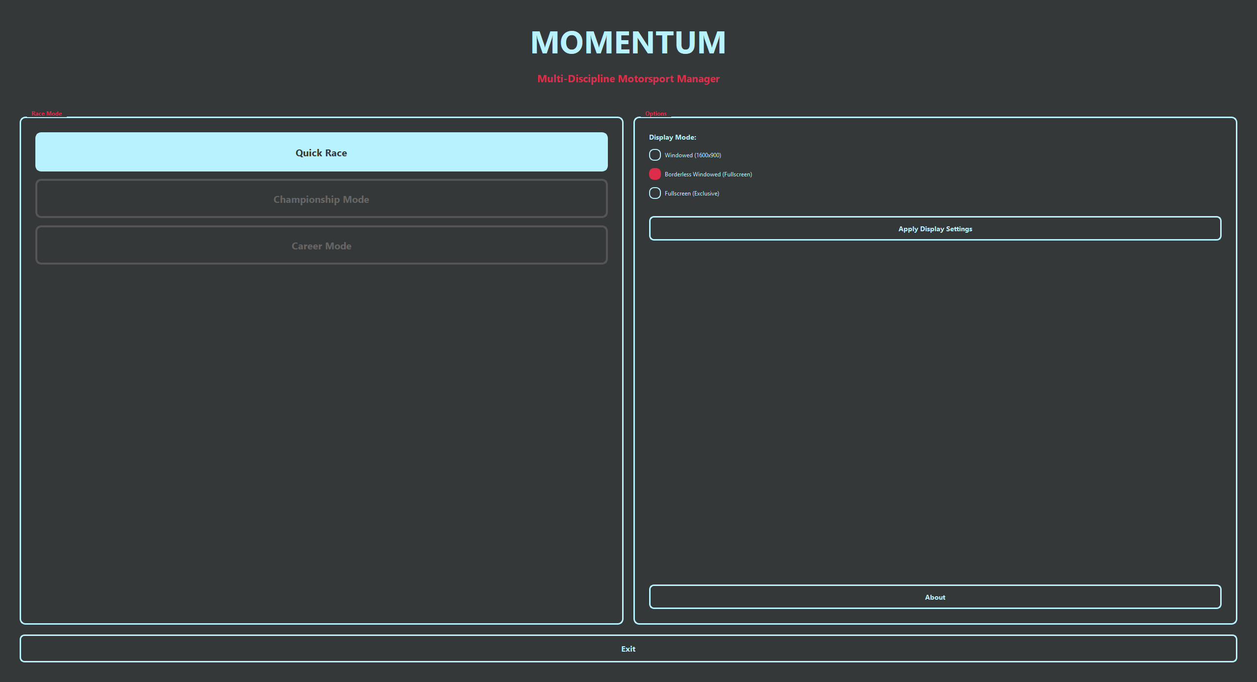
Race Screen
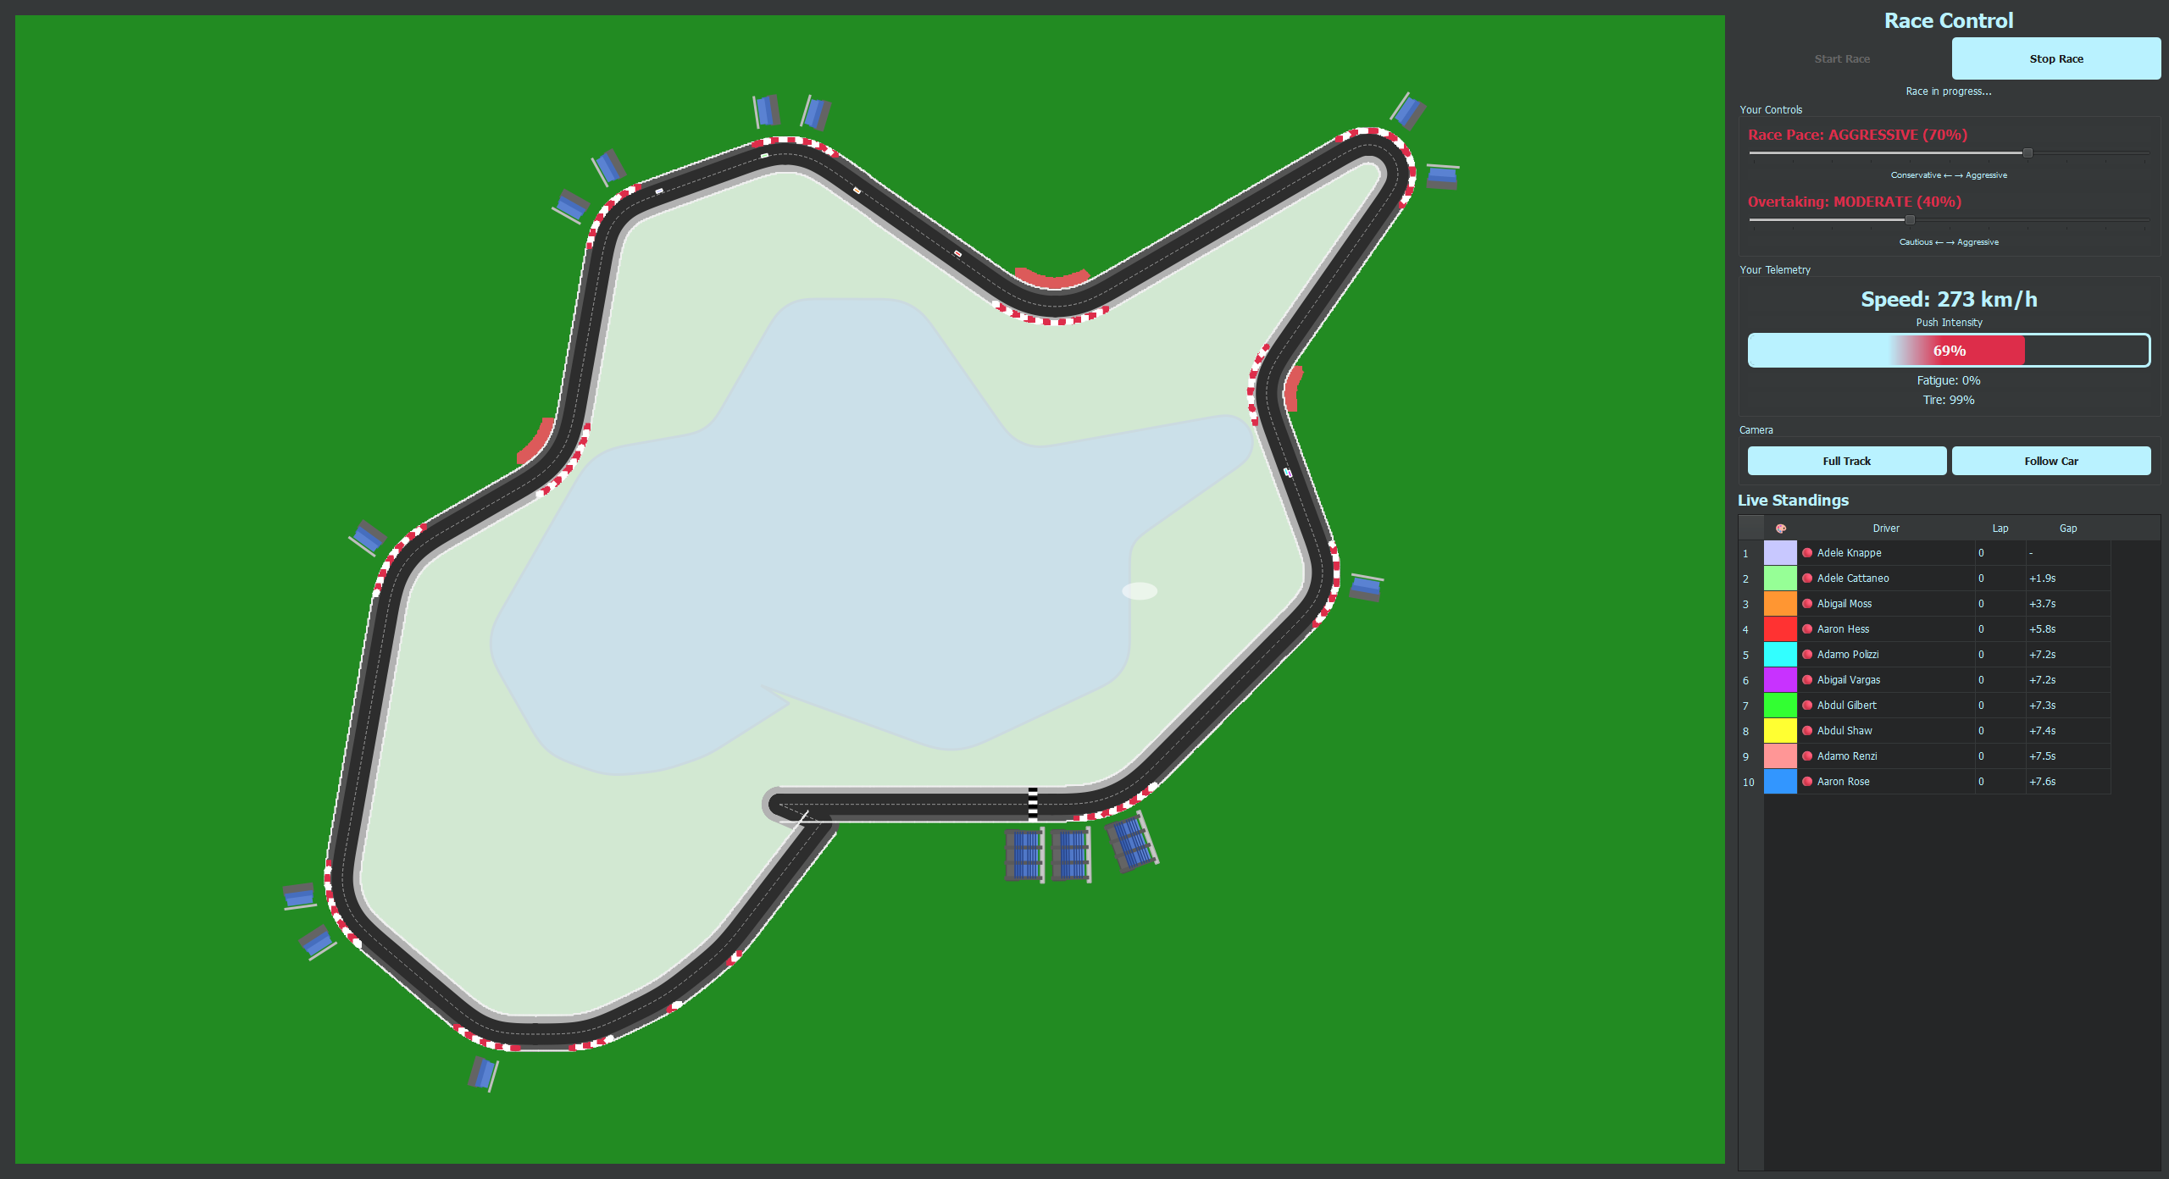

Testing
Describe any testing tools, test plans and test specifications used in the project. Provide evidence for and results of all Unit, Integration and End User testing that is carried out.

Evaluation
How was the system evaluated and what are the results? This may consist of usage data. It may also include performance evaluations, scalability, correctness, etc. depending on the focus of the project. Quantitative results may be reported in tables or figures.

Conclusions
Describe the advantages/disadvantages, strengths and limitations of the project

Further Development or Research
With additional time and resources, which direction would this project take?

Bibliography
There are no sources in the current document.

Appendices
This section should contain information that is supplementary to the main body of the report.

Project Proposal

Ethics Approval Application (only if required)

Reflective Journals

Invention Disclosure Form (Remove if not completed)
Please fill in the following sections, if you think your idea is innovative:
1. Title of Invention

2. Inventors
Name | School/Research Institute | Affiliation with Institute (i.e. department, student, staff, visitor) | Address, contact phone no., e-mail | % Contribution to the Invention

3. Contribution to the Invention
Each contributor/potential inventor should write a paragraph relating to his/her contribution and include a signature and date at the end of the paragraph.

4. Description of Invention
(Please highlight the novelty/patentable aspect. Attach extra sheets if necessary including diagrams where appropriate). What is novel, the ‘inventive step’? For more information on patents, please look at http://www.patentsoffice.ie/en/patents.aspx

5. Why is this invention more advantageous than present technology?
What is its novel or unusual features? What problems does it solve? What are the problems associated with these technologies, products or processes? Explain how this invention overcomes these problems (i.e. what are its advantages).

6. What is the current stage of development / testing of the invention?

7. List the names of companies which you think would be interested in using, developing or marketing this invention

8. Funding Partner(s)
Government Agency & Department
% Support
Contract/Grant No.
Contact Name
Phone No.
Address

Industry or other Sponsor
% Support
Contract/Grant No.
Contact Name
Phone No.
Address

9. Where was the research carried out?

10. What is the potential commercial application of this invention?

11. Was there transfer of any materials/information to or from other institutions regarding this invention?
If so please give details and provide signed agreements where relevant.

12. Have any third parties any rights to this invention?
If yes, give names and addresses and a brief explanation of involvement.

13. Are there any existing or planned disclosures regarding this invention?
Please give details.

14. Has any patent application been made? Yes/No

If yes, give date: _______________ Application No.: _______________

Name of patent agent: _________________________________________

Please supply copy of specification.

15. Is a model or prototype available? Has the invention been demonstrated practically?

I/we acknowledge that I/we have read, understood and agree with this form and the Institute’s Intellectual Property and Procedures and that all the information provided in this disclosure is complete and correct.

I/we shall take all reasonable precautions to protect the integrity and confidentiality of the IP in question.

Inventor: ______________________________ _______________________
Signature Date

_____________________
Signature

Other materials used
Any other reference material used in the project for example evaluation surveys etc.

